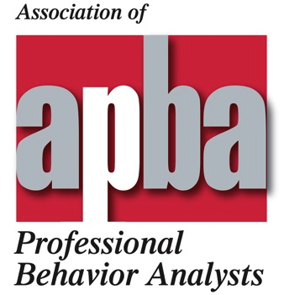
Call for Posters
2nd Annual Convention ∗ April 12-14, 2012 ∗Tampa, FL
Submission Deadline: 5 pm EST January 15, 2012
(No submissions accepted after this date)

The 2012 APBA convention will include one poster session designed to highlight empirical research that is directly relevant to the practice of applied behavior analysis. We welcome submissions from practicing behavior analysts working in service delivery, academic, and research settings. Projects appropriate for submission include completed experiments that are replications of previous studies, evaluations of innovative procedures, or extensions of established procedures with new populations and/or settings.
All submissions must be submitted by email on the form that follows. Submissions will be evaluated according to the following criteria:
- The project is clearly behavior analytic and is clearly relevant to the practice of applied behavior analysis.
- The presentation is scholarly or scientific and is not designed primarily to promote or market any product, service, agency, program, materials, etc.
- The research question, design, methods, results, and conclusions are described clearly but succinctly. Graphs or tables representing the results are included in the abstract.
- The author(s) should describe how functional control of behavior can be asserted.

POSTER SUBMISSION • 2012 APBA Convention
Please type all information and complete all fields (incomplete submissions will not be considered). Email completed, signed submission form to apbafacebook@gmail.com
Deadline: 5 pm EST January 15, 2012

Title (no more than 15 words): _______________________________
________________________________________________________
________________________________________________________

Corresponding author:

_________________________________________________________
Name Highest degree Certification or license

_________________________________________________________
Primary affiliation (one only)

_________________________________________________________
Address

_________________________________________________________
City State/Province Postal code Country

_________________________________________________________
email Phone

Presenting author (if different from corresponding author; if not, enter SAME on first line only):

_________________________________________________________
Name Highest degree Certification or license

_________________________________________________________
Primary affiliation (one only)

_________________________________________________________
Address

_________________________________________________________
City State/Province Postal code Country

_________________________________________________________
email Phone

Author 2:

_________________________________________________________
Name

_________________________________________________________
Primary affiliation (one only)

Author 3:

_________________________________________________________
Name

_________________________________________________________
Primary affiliation (one only)

Author 4:

_________________________________________________________
Name

_________________________________________________________
Primary affiliation (one only)

Abstract (APA style; no more than 150 words of text plus data graph or table):

By affixing my name below, I attest that the information above and all attachments hereto are true and accurate. If this submission is accepted, I agree to present the poster at the designated time and place at the APBA convention, or to arrange for it to be presented. I understand that failing to deliver an accepted poster or arrange for it to be presented may result in rejection of future submissions from this author. I also understand that the presenting author and any other authors who wish to attend the poster session must register for the convention.

___________________________________________________________
Corresponding author Date

Thank you for sending your completed, signed submission form to apbafacebook@gmail.com no later than 5 pm Eastern time on January 15, 2012.

*********************

For information about the 2012 APBA convention program, registration, advertising, and hotel reservations, please visit www.apbahome.net

